**HW-6 Image Processing**

**201133216**

**정유석**

**Screenshot**

**Original**

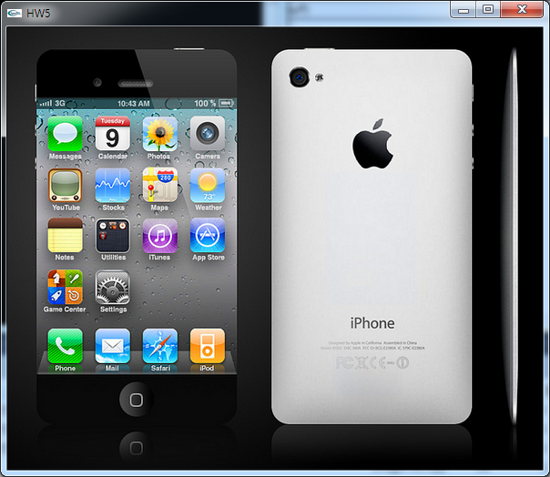

**Gray**

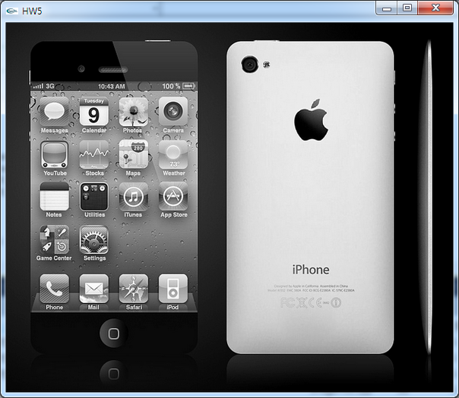

**Sepia**

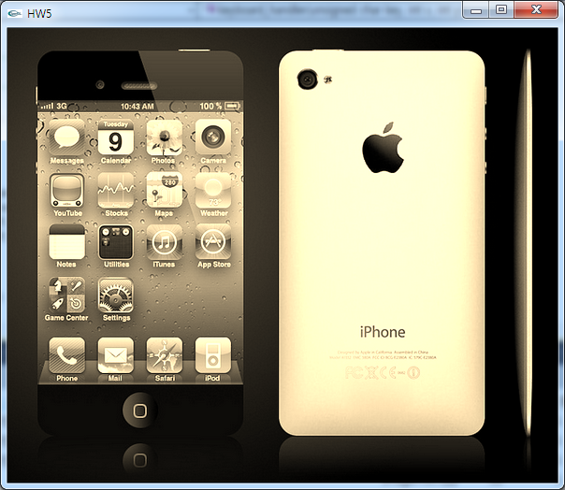

**Sampling**

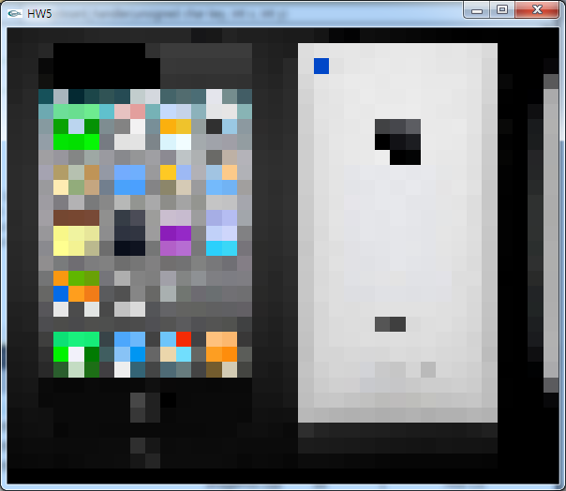

**Qunatization**

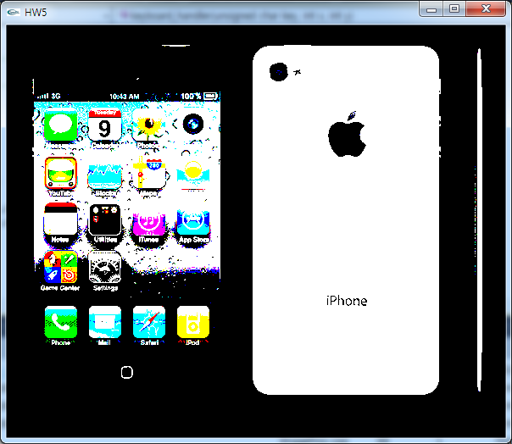

**CODE**

// ------------------------------------------------------------------------------------------------

// Convert to gray-scale

// ------------------------------------------------------------------------------------------------

void ImageProc::convertToGray()

{

int x, y; //get width, height

byte R, G, B; //get RGB from image

byte Gray; //It is used to convert gray image from orginal image

for ( y=0; y<m_iHeight; y++ )

{

for ( x=0; x<m_iWidth; x++ )

{

getPixel( x, y, R, G, B ); //get each information pixel from image

Gray = xClip( 0.299*R + 0.587*G + 0.114*B ); //Convert to gray

setPixel( x, y, Gray, Gray, Gray ); //set pixel

}

}

}

void ImageProc::convertToSepia()

{

int x, y; //get width, height

byte R, G, B;//get RGB from image

byte r2,g2,b2;//It is used to convert sepia image from orginal image

for ( y=0; y<m_iHeight; y++ )

{

for ( x=0; x<m_iWidth; x++ )

{

getPixel( x, y, R, G, B ); //get each pixel information from image

//0 ~255

r2 = xClip(R *0.393 + G*0.769 + B *0.189); //Convert to sepia each image pixel

g2 = xClip(R *0.349 + G*0.686 + B *0.168);

b2 = xClip(R *0.272 + G*0.534 + B *0.131);

//Sepia = xClip( 0.299*r2 + 0.587*g2 + 0.114*b2 );

setPixel( x, y, r2, g2, b2 );//set converting pixel

}

}

}

void ImageProc::samplingBy2()

{

// complete

int x, y; //get width, height

byte R, G, B; //get RGB from image

byte r2,g2,b2;//It is used to convert sepia image from orginal image

int newH,newW; //height/2 , width/2

newH = m_iHeight/2;

newW = m_iWidth/2;

byte *nbuf = new byte[newW * newH * 3];

for ( y=0; y<newH; y++ )

{

for ( x=0; x<newW; x++ )

{

getPixel( x*2, y*2, R, G, B ); //get each pixel information from image

//0 ~255

nbuf[x*3 + y * newW*3 +0] =R; //Convert to sampling each image pixel

nbuf[x*3 + y * newW*3 +1] = G;

nbuf[x*3 + y * newW*3 +2] =B;

}

}

m_iHeight = newH; //set new height

m_iWidth = newW; //set new width

delete[] m_pRGB;

m_pRGB = nbuf;

}

void ImageProc::quantization( int step )

{

// complete

int x, y; //get width, height

byte R, G, B; //get RGB from image

byte r2,g2,b2;//It is used to convert sepia image from orginal image

for ( y=0; y<m_iHeight; y++ )

{

for ( x=0; x<m_iWidth; x++ )

{

getPixel( x, y, R, G, B );

//0 ~255

//r2 = xClip((int)((double)(R/step +0.5)));

//g2 = xClip((int)((double)(G/step +0.5)));

//b2 = xClip((int)((double)(B/step +0.5)));

r2 = xClip(((R+(1<<step-1))>>step)<<step); //Convert to quantization each image pixel

g2 = xClip(((G+(1<<step-1))>>step)<<step);

b2 = xClip(((B+(1<<step-1))>>step)<<step);

setPixel( x, y, r2, g2, b2 ); //set pixel

}

}

}